**A**

**Project Phase- II Report on**

“DESIGN AND MANUFACTURING OF ROTARY DUST COLLECTOR”

**Submitted in Partial Fulfillment of the requirements for the award of degree of**

**“Bachelor of Mechanical Engineering”**

**OF SHIVAJI UNIVERSITY, KOLHAPUR**

**By**

**Mr. SAVEKAR SANKET RAOSO**

**Mr. PATHAK OM SHREEKANT**

**Mr. KAVANEKAR MAHESH JOTIBA**

**Mr. PATIL ABHAYKUMAR APPASAHEB**

**UNDER THE ABLE GUIDANCE OF**

**Prof. S.I.JABADE**

**(Asst. Professor in Mechanical Engg. Dept)**



**Mechanical Engineering Department**

**SGMRHRC TRUST’s**

Accredited by NAAC B++ & an ISO 9001:2015 Certified Institute

**SANT GAJANAN MAHRAJ COLLEGE OF ENGINEERING**

**MAHAGAON, SITE CHINCHEWADI.**

**2021-22**

**sgmrhrc trust’s**

Accredited by NAAC B++ & an ISO 9001:2015 Certified Institute

**SANT GAJANAN MAHRAJ COLLEGE OF ENGINEERING**

**MAHAGAON, SITE CHINCHEWADI.**



**CERTIFICATE**

This is to certify that **Mr. SAVEKAR SANKET RAOSO , Mr. PATHAK OM SHREEKANT, Mr. KAVANEKAR MAHESH JOTIBA , Mr. PATIL ABHAYKUMAR APPASAHEB** has successfully completed the Project Phase- II work Titled **“DESIGN AND MANUFACTURING OF ROTARY DUST COLLECTOR”** under my supervision, in the partial fulfillment of award of degree of Bachelor of Mechanical Engineering, in year 2021-22, being conducted by Shivaji University Kolhapur.

**Date :-**

**Place:**-

**Asst. Prof. S. I. JABADE Asst. Prof. R. V. Bammankatti**

Project Guide Project Co-Ordinator

**Asst. Prof. V. R. Ghatage Principal** **Dr. S.H.SAWANT**

Head, Mech. Engg. Dept. SGMCOE, Mahagaon

**ACKNOWLEDGEMENT**

I wish to express my profound gratitude to the almighty God for guiding me to successfully complete this work. I take this opportunity to express my deep sense of gratitude to my guide **Asst. Prof. S. I. JABADE** & Project.-Coordinator, **Prof. R. V. Bammankatti** for his continuous guidance and encouragement throughout the course of this study. Without his valuable suggestion and encouragement this would not have been possible. It is because of his experience and wonderful knowledge, I can fulfill the requirement of completing the Project Report within the stipulated time.

I would also like to thank **Prof. V. R. Ghatage**, Head of Mechanical Engineering Department and **Dr. S. H. Sawant** Principal, S. G. M. C. O. E., Mahagaon for his thorough support. I acknowledge with thanks, the assistance provided by departmental staff, central library and computer faculty staff. I find myself spellbound to acknowledge special thanks to parents for their silent support, patience, encouragement and affection without which this work would never have been possible and I thank all my colleagues for their valuable co-operation and coordination which was available time to time.

|  |  |
| --- | --- |
| **PRN NUMBER** | **NAME OF STUDENT** |
| 2019084700 | SAVEKAR SANKET RAOSO |
| 2019084740 | PATHAK OM SHREEKANT |
| 2019084706 | KAVANEKAR MAHESH JOTIBA |
| 2019084732 | PATIL ABHAYKUMAR APPASAHEB |

# INDEX

# 

# Title page……………………………………………………………………….…01

# Certificate…………………………………………………………………………02

# Acknowledgement ...…………………………………………………...03

# Introduction…………………………………………………………….05

# Objectives...…………………………………………………………....08

# Scope of Work…...…………………………………………………….08

# Relevance………………………………………………………………09

# Literature review……………………………………………………….10

# Methodology/Planning of work...……………………………………...13

# Basic Layout…………………………………………………………....14

# Basic Study and working……………………………………………….15

# Key Aspects…………………………………………………………….15

# Feasibility Study………………………………………………………...16

# Advantages and Disadvantages………………………………………....19

# Design………………………………………………………………...…20

# Calculation…………………………………………………………...….21

# Bearing Support Analysis……………………………………………….24

# Ballooning and General Assembly……………………………………...32

# Bill of material…………………………………………………………..33

# 3D CAD Modelling……………………………………………………..34

# Actual Images of Machine……………………………………………....35

# Future Scope…………………………………………………………,….37

# Conclusion…………………………………………………………….…38

# Reference………………………………………………………………...39

# 1. Introduction:

All sorts of textiles and substances are used for the work within the textile industry. During these processes lots of dust particles are produced, which remain suspended in the air within the hall, settle out (high cleaning costs) and, above all, can cause various health problems and also decrease the quality of the fabric. To prevent this an air cleaning and dust extraction system should be installed. Particularly raw materials such as raw wool, synthetic fibers and raw cotton cloth can cause health problems. Above all, it is the small dust particles in these raw materials that cause a problem, because they can be inhaled deeply within the lungs. These dust particles can also be endotoxins, which means they are poisonous. These Rotary Dust Collector sucks the small dust particle from the cloth by using vacuum mechanism and make it clean. Special Trenches are made for taking out the dust. This done while the civil work of factory. These trenches are working as dust ducts. Every machine has small holes near its foundation for the escape of dust and waste material.

In this project we are responsible for making the dust collector which actually helps in sucking the dust. Dust collector is basically a rotating drum wound with cotton fabric with an arrangement for suction from periphery and one end of roller is packed while on other end fan is mounted which actually creates the suction required. We will be only considering the design of roller drum and its mounting as our scope of project.

A rod connecting to the bag is powered by a motor. This provides motion to remove caked-on particles. The speed and motion of the shaking depends on the design of the bag and composition of the particulate matter. Generally shaking is horizontal. The top of the bag is closed and the bottom is open. When shaken, the dust collected on the inside of the bag is freed. No dirty gas flows through a bag while it is being cleaned. This redirection of air flow illustrates why baghouses must be compartmentalized

Air flow gives the bag structure. Dirty air flows through the bag from the inside, allowing dust to collect on the interior surface. During cleaning, gas flow is restricted from a specific compartment. Without the flowing air, the bags relax. The cylindrical bag contains rings that prevent it from completely collapsing under the pressure of the air. A fan blows clean air in the reverse direction. The relaxation and reverse air flow cause the dust cake to crumble and release into the hopper. Upon the completion of the cleaning process, dirty air flow continues and the bag regains its shape.

This type of baghouse cleaning (also known as pressure-jet cleaning) is the most common. It was invented and patented by MikroPul in 1956.[[6]](https://en.wikipedia.org/wiki/Dust_collector#cite_note-6) A high pressure blast of air is used to remove dust from the bag. The blast enters the top of the bag tube, temporarily ceasing the flow of dirty air. The shock of air causes a wave of expansion to travel down the fabric. The flexing of the bag shatters and discharges the dust cake. The air burst is about 0.1 second and it takes about 0.5 seconds for the shock wave to travel down the length of the bag. Due to its rapid release, the blast of air does not interfere with contaminated gas flow. Therefore, pulse-jet baghouses can operate continuously and are not usually compartmentalized. The blast of compressed air must be powerful enough to ensure that the shock wave will travel the entire length of the bag and fracture the dust cake. The efficiency of the cleaning system allows the unit to have a much higher gas to cloth ratio (or volumetric throughput of gas per unit area of filter) than shaking and reverse air bag filters.[[7]](https://en.wikipedia.org/wiki/Dust_collector#cite_note-7) This kind of filter thus requires a smaller area to admit the same volume of air.

The least common type of cleaning method is sonic. Shaking is achieved by sonic vibration. A sound generator produces a low frequency sound that causes the bags to vibrate. Sonic cleaning is commonly combined with another method of cleaning to ensure thorough cleaning.

Although the principles of this method are basic, the rotating mechanical cage cleaning method is relatively new to the international market. This method can be visualized by reminding users of putting a floor covering rug on a [clothes line](https://en.wikipedia.org/wiki/Clothes_line) and beating the dust out of it. The rotating cage consists of a cage with fixed position holding the filter bag. Nested inside the cage holding the bag is a secondary cage that is allowed to rotate 90 degrees. This rotating action can be as adjusted to meet desired whipping effect on the inside of the bag.[[8]](https://en.wikipedia.org/wiki/Dust_collector#cite_note-8)

a mechanical cage inside a dusty bag moving to beat off the built-up material

Actuation of a rotating mechanical cage for dust removal on filter media

Cartridge collectors use perforated metal cartridges that contain a pleated, nonwoven filtering media, as opposed to woven or felt bags used in baghouses. The pleated design allows for a greater total filtering surface area than in a conventional bag of the same diameter, The greater filtering area results in a reduced air to media ratio, pressure drop, and overall collector size.

Cartridge collectors are available in single use or continuous duty designs. In single-use collectors, the dirty cartridges are changed and collected dirt is removed while the collector is off. In the continuous duty design, the cartridges are cleaned by the conventional pulse-jet cleaning system.

**2. Objectives:-**

1. To clean and maintain the quality of cloths.
2. To clean the cloth by using vacuum/suction method.
3. To reduce the overall weight and cost of the machine.
4. To design the more effective than previous one.

**3. Scope of Work:-**

The “Rotary Dust Collector” is one of the simplest machines for textile industrial mechanical applications and mechanical operations. It has the efficient practical approach for the separation of dust particle from the fabric. Rotary Dust Collector has an exclusive mechanism for sucking dust particle from the cloth with minimum labour operating cost. The operation performed with the help of “Rotary Dust Collector” is considered as one of the energy efficient and clean method for filtration of cloth. The various parameters such as vacuum pressure, rate of rotation can affect the filtration rate and quality of filtrate. It has the capability of continuous flow processing during the phase of dust collection. The fact about rotary dust collector is that it is considered as the vacuum cleaner for fabric in textile industries.

**4. Relevance:-**

Although the principles of this method are basic, the rotating mechanical cage cleaning method is relatively new to the international market. This method can be visualized by reminding users of putting a floor covering rug on a clothes line and beating the dust out of it. The rotating cage consists of a cage with fixed position holding the filter bag. Nested inside the cage holding the bag is a secondary cage that is allowed to rotate 90 degrees. This rotating action can be as adjusted to meet desired whipping effect on the inside of the bag

Axial-flow fans are used in systems that have low resistance levels. These fans move the air parallel to the fan's axis of rotation. The screw-like action of the propellers moves the air in a straight-through parallel path, causing a helical flow pattern.

The three main kinds of axial fans are:

**Propeller fans** - These fans are used to move large quantities of air against very low static pressures. They are usually used for general ventilation or dilution ventilation and are good in developing up to 0.5 in. wg (124.4 Pa).

**Tube-axial fans** - Tube-axial fans are similar to propeller fans except they are mounted in a tube or cylinder. Therefore, they are more efficient than propeller fans and can develop up to 3 to 4 in. wg (743.3 to 995 Pa). They are best suited for moving air containing substances such as condensable fumes or pigments.

**Vane-axial fans** - Vane-axial fans are similar to tube-axial fans except air-straightening vanes are installed on the suction or discharge side of the rotor. They are easily adapted to multistage and can develop static pressures as high as 14 to 16 in. wg (3.483 to 3.98 kPa). They are normally used for clean air only.

Important parameters in specifying dust collectors include airflow the velocity of the air stream created by the vacuum producer; system power, the power of the system motor, usually specified in horsepower; storage capacity for dust and particles, and minimum particle size filtered by the unit. Other considerations when choosing a dust collection system include the temperature, moisture content, and the possibility of combustion of the dust being collected

**5. Literature review:-**

Prof. Sumit S. Dharmarao, Ravindra B. Bantanur, Abu-Rehan J. Bedrekar, Rohit R. Patil presented paper on “Development of Low-Cost Dust Collector for Textile Industry”. This paper explains that, Cotton dust in the work place is major problem in cotton textile industries. This problem is more severe in spinning section. Dust consists of small and microscopic particles of various substances which are present as suspended particles in air. These particles are harmful to human health. Because of these various diseases are occurred like shortness of breath, cough, and lungs cancer. Various aspects of health hazards in textile industries have been discussed and measure hazards is lungs cancer to reduce this health hazards are lungs cancer our dust collector is helpful.

B.M.Sangeetha, M.Rajeswari, S.Atharsha, K.Saranyaa Sri, S.Ramya presented paper on “Cotton Dust Level in Textile Industries and Its Impact on Human”. This paper explains that In India, the textile industry contributes substantially to the foreign exchange earned by the country. The textile industry is providing employment opportunities to numerous people in the country. The emphasis on awareness about the environmental concern such as air, water and noise pollution during the processing from fiber to fabric is essential in the present circumstances. Information regarding cotton dust exposure impacts and the control strategies is lacking among textile employers and its management. The main aim of this paper is to provide, dust level in the textile industry and the available air quality standards are discussed to facilitate textile mill employers and management to establish cotton dust control strategies to save their workers from its harmful impacts. The study has been carried out in textile industries located in Tirupur. This study is based on the analysis and monitoring of air pollutants using respiratory dust sampler in work place.

Abera Kumie, Magne Bratveit, Wakgari Deressa, Samson Wakuma, Bente E. Moen presented paper on “Personal cotton dust exposure in spinning and weaving sections of a textile factory, north Ethiopia”. This paper tells us about the growing textile industry in Ethiopia has had a profound impact on employment opportunities in the country. Exposure to cotton dust is well recognized to cause respiratory illnesses among workers. However, exposure assessments of textile workers are rarely conducted in Ethiopia. This study aimed at measuring personal exposure to total cotton dust among textile factory workers and to explore the variability of dust exposure in different factory work sections.

Uman Khalid, Muhammad Faizan Baloch, Haseeb Haider, Muhammad Usman Sardar, Muhammad Faisal Khan, Abdul Basit Zia and Tahseen Amin Khan Qasuria presented paper on “Smart Floor Cleaning Robot (CLEAR)”. This paper explains with the advancement of technology, robots are getting more attention of researchers to make life of mankind comfortable. This paper presents the design, development and fabrication of prototype Smart Floor Cleaning Robot (CLEAR) using IEEE Standard 1621 (IEEE Standard for User Interface Elements in Power Control of Electronic Devices employed in Office/Consumer Environments). Subject robot operates in autonomous mode as well as in manual mode along with additional features like scheduling for specific time and bagless dirt container with auto-dirt disposal mechanism. This work can be very useful in improving life style of mankind.

Manisha Kukde, Sanchita Nagpurkar, Akshay Dhakulkar, Akshay Amdare presented paper on Automatic & Manual Vacuum Cleaning Robot.In this work author implemented a human friendly cleaning robot with the advancement of technology to make human life easy and comfortable. The conventional automatic cleaning robot already exists, but these robots do not work sync with humans. This robot can work in any of two modes i.e., “Automatic and Manual’’. The need of the project has come up because of a busy schedule of a working people. So, this has resulted in coming up with an objective of making an automated vacuum cleaner. Vacuum cleaner robot which having components DC motors, wheels, roller brush, cleaning mop, the garbage container and obstacle avoidance sensor & 12V rechargeable battery is used as power supply. The study has been done keeping in mind economic cost of product. Manual work is done by robot technology. RF modules have been used for wireless communication between remote (manual mode) and robot and having range 50m. In this vacuum cleaning robot for obstacle detection IR sensor is used. Four motors are used, two for cleaning, one for water pump and one for wheels. Motor driver IC is used to drive the motors & MOSFET is used for water pump and another for cleaner as switching. In previous system, there was no automatic water sprayer used and works only in automatic mode. In the automatic mode robot control all the operations itself and change the lane in case of hurdle detection and moves back. In the manual mode, the remote is used to perform the expected task and to operate robot. In manual mode, RF module has been used to transmit and receive the information between remote and robot and display the information related to the hurdle detection on LCD. The whole circuitry is connected with 12V battery.

V.S. Shaisundaram, S. Sivabalan, S. Indharesh, M. Jitendra, A. Aravindharaj presented paper on “Design and Fabrication of Unit Modular Dust Collector”. This paper explains the trend among mechanical industries to develop selective granular solid of high potential has pushed the industry to consider the potential of each hazardous ingredient to become airborne. Dustiness issues are not unique to the mechanical industry, but are relevant to any industry where powdered materials are mixed, transferred and handled. Interest in dustiness is also driven by concerns for workers health, the potential for plant explosions and the prevention of product loss. Unlike other industries, the mechanical industry is limited by the milligram quantity of solid material available for testing during product development. A dust collector is a system used to enhance the quality of air released from industrial and commercial processes by collecting dust and other impurities from air or gas. Designed to handle high-volume dust loads, a dust collector system consists of a blower, dust filter, a filter-cleaning system, and a dust receptacle or dust removal system. It is distinguished from air purifiers, which use disposable filters to remove dust. In this project we are going to design Unit Modular Dust Collector, also called as bag filter. We need to sketch 2D Design from Autocad. Then 2D is converted to 3D in Catia. In general, the finer the particles that have to be collected, the higher will be the cost of a suitable separation system.

**6.Methodology / Planning of work:-**

Figure 1. Methodology



**General Industrial Survey**

**Planning**

**Prototype Making**

**Research**

**Design & Development Machine**

**Trials of Machine**

**Manufacturing of Dust Collector**

**7.Basic Layout:-**

Figure 2.Basic Layout

Suction pipe

Roller drum

Suction Arrangement Mounting

motor

shaft

From basic layout we can understand that there is going to be a roller support structure for just supporting the cotton cloth and this of maximum possible round shape so that large amount of dust can be collected at a one time. At one end of this roller structure large rotating fan is attached which creates a suction within the roller drum which enables all dust to come towards the drum cloth. One end of drum is closed. Because of suction all dust and cotton waste is collecting over round envelope of cotton cloth over the drum. One suction arrangement is attached axially over the periphery of drum to suck that waste and collect ed in the sacks which are outside the room.

Here we are supposing to design the structure of drum, shafts for rotating the drum, selection of motor, selection of drive, etc.

We would be selecting the pillow block bearings for mounting of the shaft and also designing the pillow block supports.

**8.Basic Study and working :-**

Rotary drum filter is made of sheet steel which are assembled to form a drum. The rotating drum provides the ample area for filtration, fitted with variety of filter media for different type of dust and waste. The material deposited on the filter media is sucked off with smooth sliding nozzles connected to powerful suction blower through a cyclone and bag filters.

We can increase the number of suction nozzles to increase the efficiency and for the faster collection of micro dust.

**9.Key Aspects:**

1. Continuous cleaning, therefor no pressure fluctuation within system.
2. Precise adaption to the total air volume due to the modular design.
3. Energy efficient operation due to low pressure loss.
4. Wide range of filtration capacity is available due to easy construction.

Various images of dust collectors available in market are as follows which gives the basic idea about their working and construction.

**9.Images Of Rotary Dust Collector:-**

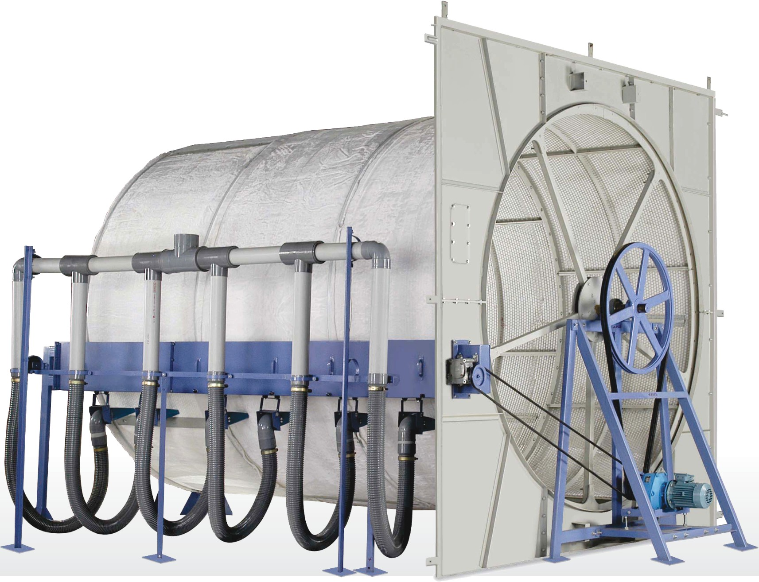

Figure 3.Dust Collector Reference Image 1

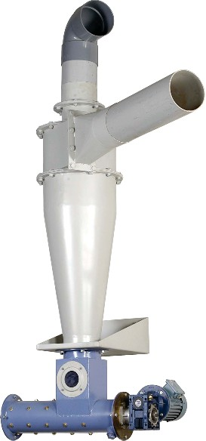

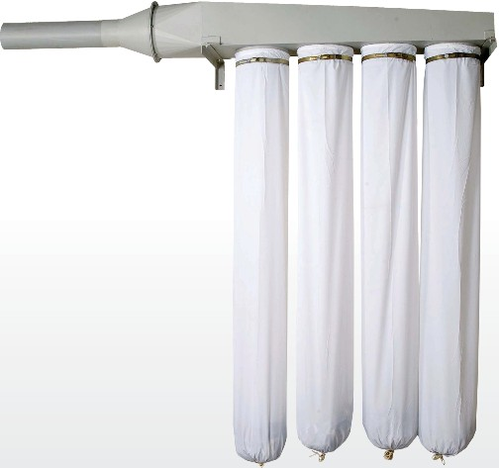

Figure 4.Dust Collector Reference Image 2

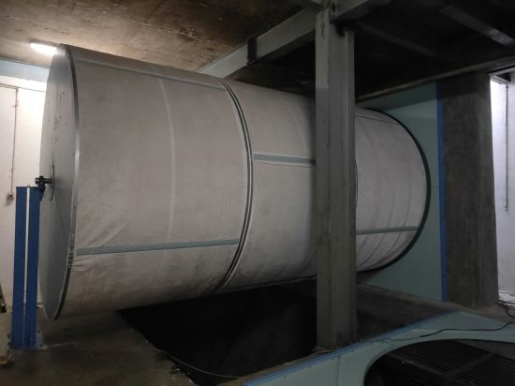

Figure 5.Dust Collector Reference Image 3

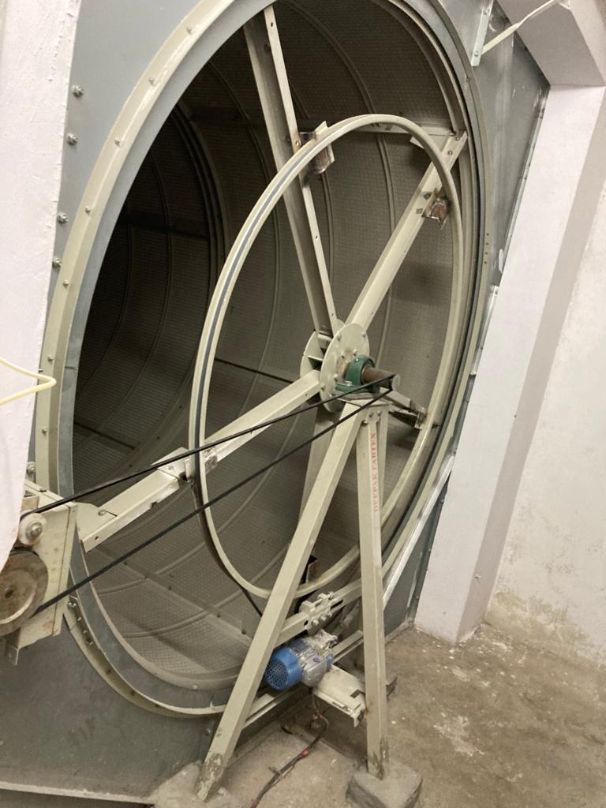

Figure 6. Dust Collector Reference Image 4

**10.Feasibility Study:-**

There are various researchers have worked on phenomenon of dust collection in Textile Industry but there is very few research on collection of dust particle on cloth. Also, many researchers have focused on the Semi-Automatic Dust Collector, but our main focus is to design and Manufacture Automatic Dust Collector which collect dust continuously while manufacturing.

**11.Advantages And Disadvantages:-**

* **Advantage:**

A. Improve the quality of the fabric.

B. Decrease the time to check the cloth whether it is dusty or not.

C. Decrease the employee health factor.

D. Low maintenance cost.

* **Disadvantage:**

A. High initial cost.

B. It makes too much noise.

C. It is compatible only for large scale industries.

D. Require Large space to install.

**12.Design:-**

1. **Selection of Motor**

Mass of Rolling Drum is 290.11 kg which Approximately Considered as 300 kg.

We have modelled the drum in CAD software and calculated its moment of inertia about rotating axis and it is found that I xx = 1604.28 kg.m2

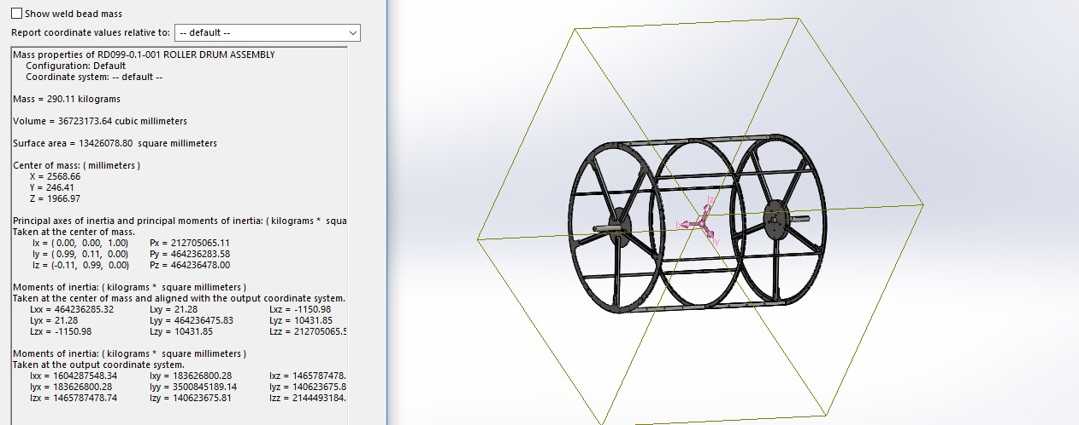

Figure 6. Evaluation of Model Using CAD

While selecting we have to consider the rotational inertia resistance of rotating equipment and the frictional contact resistance. So, let’s calculate each of them:

**13. Calculation:-**

**Inertia Resistance**

T= I * α

α = dw/dt

The rotational rpm we want is 8 rpm and that to in 3 sec.

w= 2* 3.14 * N / 60 = 2*3.14*8/60 = 0.83

α = 0.83/3= 0.276 rad/sec2

Rotational Inertial Torque = 1604.28 * 0.276

= 442.78 N.m

Therefore, Power Required = 442.78 * 2* 3.14* 8 / 60

= 367.50 Watt

1. **Frictional Torque** = 300*9.81*32.5*10-3*0.05 = 4.782 Watt

So, total Wattage required in order to rotate the drum is equal to = 367.50 + 4.782

= 372.29

= 0.49 Hp

Consider the factor of safety of 2.

Hence, we have decided to use 1 Hp motor for rotation of the shaft and ultimately roller drum.

2)Selection of Bearing:-

As we know that total load that is acting on bearing is 300 kg which is in vertical direction and it is uniformly distributed hence the vertical reactions at bearing support

=300*9.81/2=1471.5 N

Now, we are supposed to calculate the horizontal reaction due to the belt tension.

Let’s calculate the pulley tension acting at the end of shaft =

(Power in hp *745.7)/w*r

= 1*745.7/0.83*32.5*10-3

= 27644.11 N

Above value is T1-T2.

And we know T1/T2= eμθ

T1=34.91 KN, T2=7.27KN

Hence total belt pull is 34.91+7.27 = 42.19 KN

Draw the FBD for horizontal reactions,

R1

42193 N

160 mm

2480 mm

R2

R2 - R1 = 42193 N and R1*2480 = 42193*160

By using above 2 equations we can calculate R1=2722.17 and R2 = 44915.17 N

Hence, we can see net resultant force is maximum at R2. And can be calculated as = (44915.172+1471.52)0.5 = 44939.26 N = 44.939 KN

This force is acting radially hence we are going to select pillow block bearing which can only able to bear radial force with very small thrust load carrying capacity for manufacturing irregularities.

3)Shaft Calculation:-

Shaft is subjected to bending moment of 44939.26*160 = 7.19 KN.m

And the twisting moment is 27644.11*65*0.5=0.898 KN.m

Let’s consider the shaft material as 45C8 580 whose Sut = 600 MPa, S yt = 380 N/mm2

As per ASME Code,

τ max = 0.3 S yt / 0.18 Sut Whichever is minimum.

= 0.3*380 / 0.18*600

= 114 / 108

= 108 MPa

ASME Code is based on maximum shear stress theory.

τmax = 16/πd3√(kbMb)2 + (ktMt)2

kb =1.5, kt = 1

Hence d = 7.99 mm So Safe diameter for shaft is 8 mm.

We have decided to use the shaft as a pulley. So as a thumb rule, we have decided to go for 65 mm diameter shaft.

As our shaft dimeter is selected, we can really go for the section of bearing.

Let’s select the bearing and calculate the life of bearing.

Select the bearing P2B 65M-TF by SKF. Its dynamic load carrying capacity is 57.2 KN.

Let’s calculate the life of bearing:

L10 = (C/P)3 = (57.2/44.93)3 = 2.06 million revolutions

Our bearing is rotating at speed of 8 rpm and we are working for 24 hours.

Hence, Rotations per day = 8*60*24= 11,520 rev per day

Hence life in days = 2.06*106 / 11520 = 178 Days.

Which is enough in our case.

**14.Bearing Support Analysis:-**

Bearing support are modeled and then they are checked for the loading on it. In actual only weight of the roller assembly is coming on the support. And this load is 300 kg and when it is distributed on 2 supports it becomes 150 kg on each support which is equal to 1471.5 N.

While checking the both structures we have selected basic structural steel as a material and its base support is made fixed and load of 1471.5 N is applied on upper face. Let’s see the results for both the structural supports in given figures below:

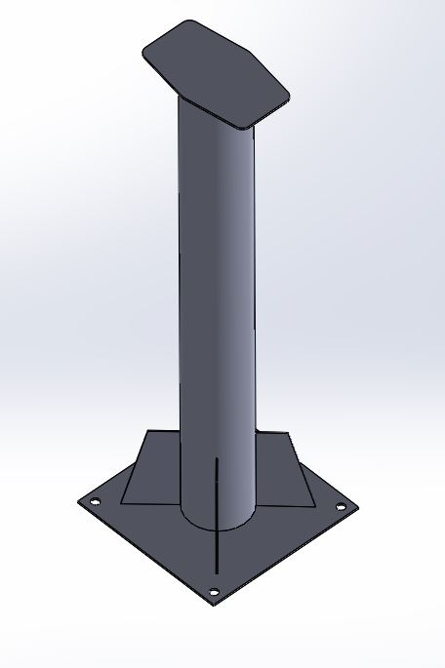

Figure 7.Roller Support 1 model

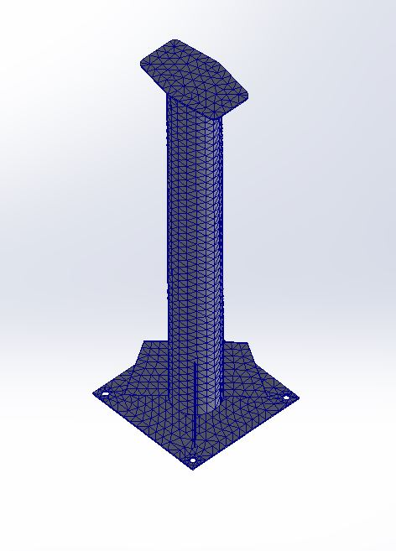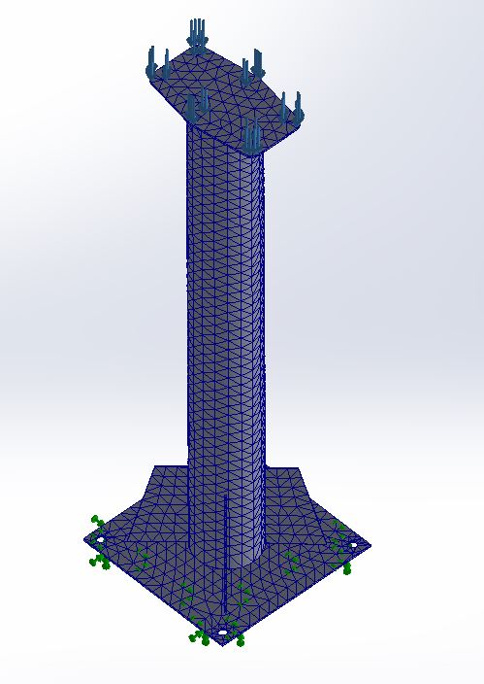

Figure 8. Roller support 1 mesh, constraints and loading condition

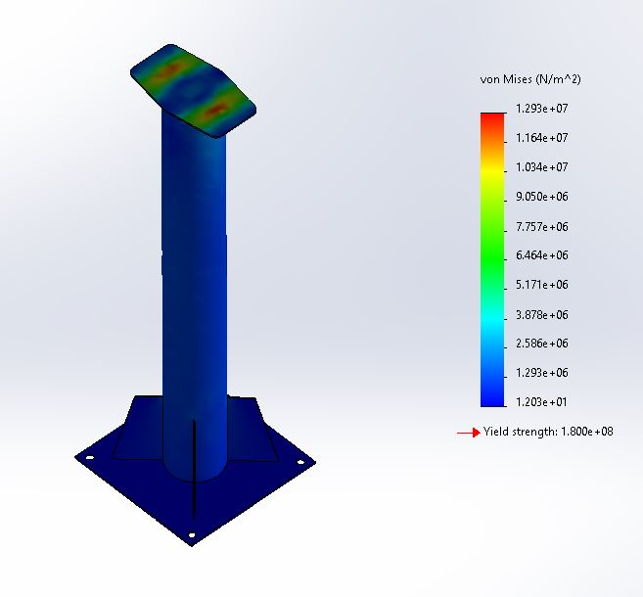

Figure 9. Von mises stress theory results of roller support 1

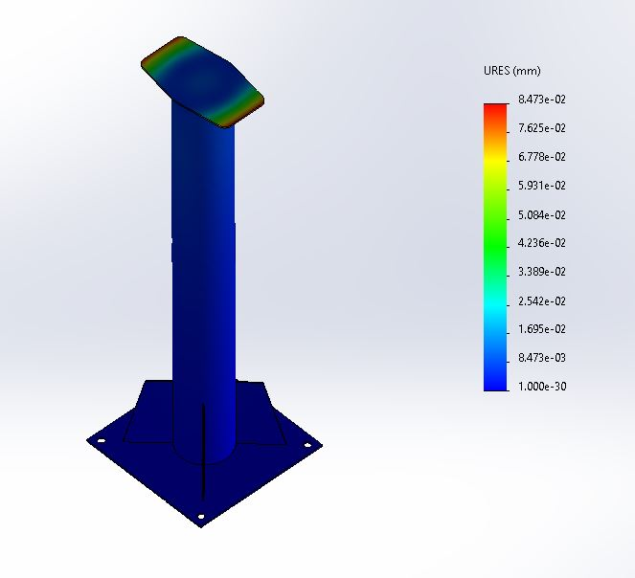

Figure 10. Deformation results of roller support 1

From Above figures we can see where the structure is fixed and the how the loads are applied. At the same time, we can see the maximum stress is 12.93 MPa. We have used von mises theory because the material which we are using is structural steel which is ductile in nature. And for ductile materials Von Mises theory is most appropriate theory. While Maximum Shear stress theory give the over safe results while the Maximum Principal stress theory give the under safe results. Yield strength of structural steel is 250 Mpa hence factor of safety is 250/12.93 = 19.33 which is enough and the maximum deformation is 0.84 μm which is allowed as it won’t hamper the functioning of the system. Hence our structure is safe.

Let’s Discuss about the roller support 2. Material applied for this is structural steel whose Syt = 250 MPa. Below figures shows the detail about model, constraint, loads and the results.

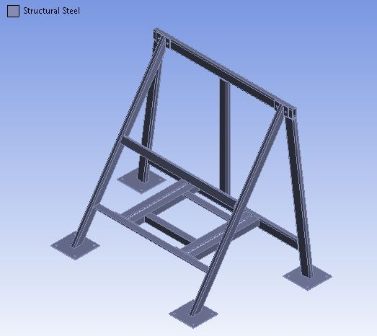

Figure 11. Model of Roller support structure 2

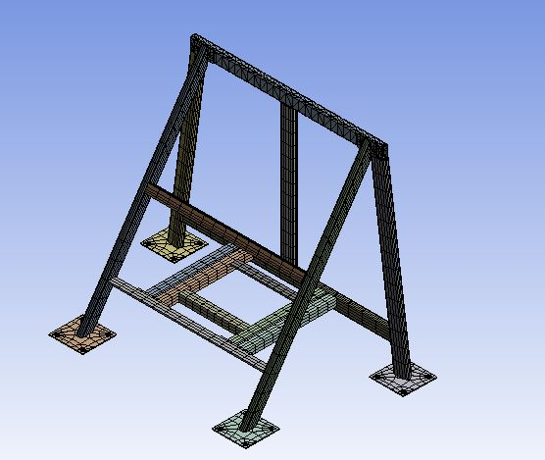

Figure 12. Mesh model of roller support structure 2

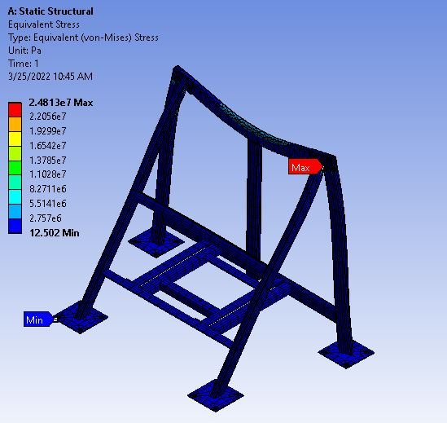

Figure 13. Von mises stress theory results for Roller support 2

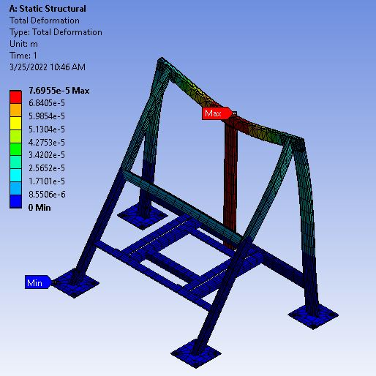

Figure 14. Deformation results for Roller support structure 2

From Above analysis we can see the maximum Von mises stress is 24.81 MPa and the maximum deformation is 0.76 μm which is within permissible range and will not harm the functionality of parts. Factor of safety for above structure is 250/24.81 = 10.07. Hence, we can say that designed structure is safe.

**15.Ballooning and General Assembly:-**

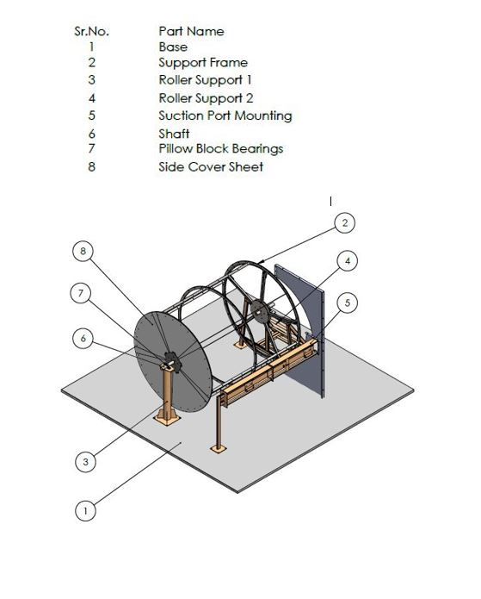

Figure 15.Model Ballooning

**16.Bill of Material:-**

|  |  |  |  |
| --- | --- | --- | --- |
| Sr. No. | Part Name | Quantity | Material |
| 1 | Roller Support 1 Base Plate | 1 | Mild Steel |
| 2 | Roller Support 1 Pipe | 1 | Mild Steel |
| 3 | Roller Support 1 Side Gusset | 4 | Mild Steel |
| 4 | Roller Support 1 Top Plate | 1 | Mild Steel |
| 5 | Drum Side Plate | 24 | Mild Steel |
| 6 | Roller Drum Supporter | 10 | Mild Steel |
| 7 | Drum Support Square Pipe | 10 | Mild Steel |
| 8 | Roller Drum Circular plate | 4 | Mild Steel |
| 9 | Shaft | 2 | Mild Steel |
| 10 | Roller support 2 frame | 1 | Mild Steel |
| 11 | Bearing Support Plate | 1 | Mild Steel |
| 12 | M16 x 100 bolt and nut | 29 | Mild Steel |
| 13 | M12 x 90 bolt and nut | 1 | Mild Steel |
| 14 | M8 x 40 x 22 bolt and nut | 10 | Mild Steel |
| 15 | M12 x 50 x 30 bolt and nut | 8 | Mild Steel |

Table 1.Bill of Material

**17. 3D CAD Modelling:-**

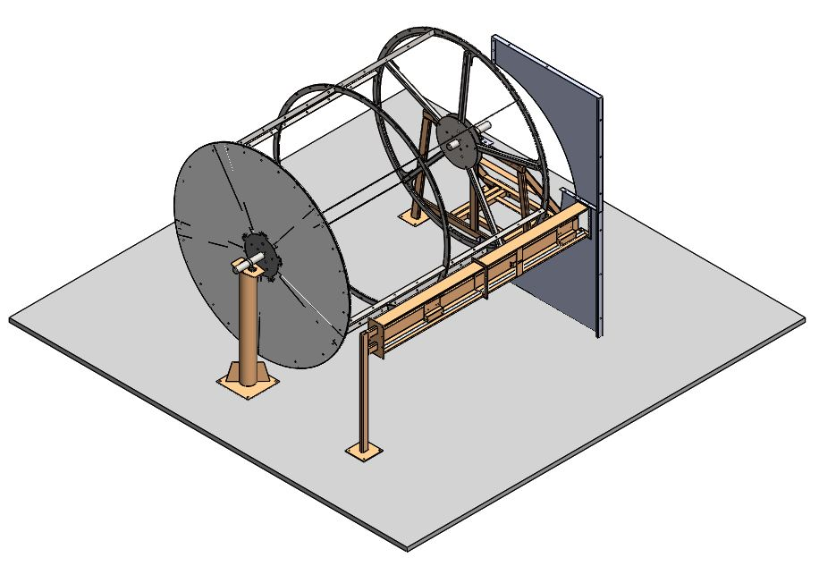

Figure 16. 3D Model

**18. Actual Images of Machine:-**



Figure 17.Actual Machine Image 1

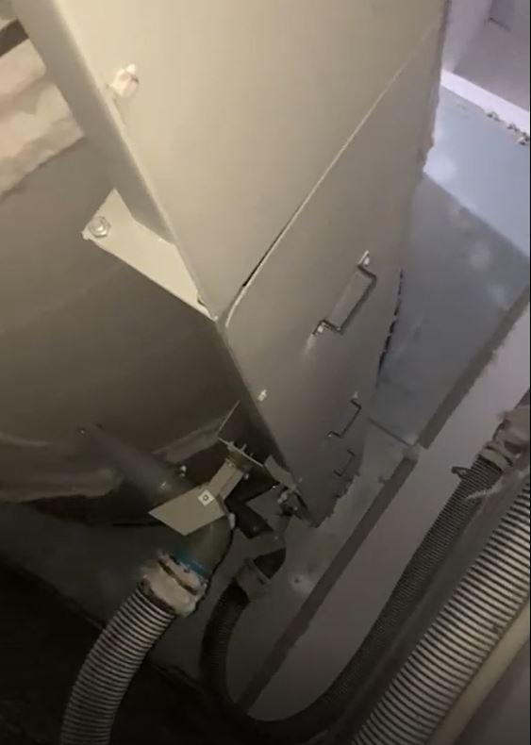

Figure 19.Actual Machine Image 2

**19. Future Scope:-**

After studying the rolling drum filter, we have understood that we can add some more layers of filters for improving the filter process and at the same time we can increase the power of system to increase the efficiency of system.

The size of roller drum filter is very high which leads to an excess amount of investment in civil infrastructure where we can develop our system to be less bulky while keeping effectiveness same as of previous.

There is also a scope for automatic adaptable system which adjusts on its own depending on the waste and dust load in order to decrease the power consumption.

Our model can be modified to ease the manufacturability and the assembly of the product.

**20.Conclusion:-**

We have successfully designed the rotating dust collector and installed that on site. And at the same time, we have checked the reliability of all the components and found perfectly suitable to perform their functionality. All components are working up to expectations.

Because of the installation of dust collector, significant reduction in cotton waste and dust is observed at shop floor. And there is big relief for the workers working on shop floor. Total 3-4 bags of cotton waste are getting collected daily in collecting bags. Because of the dust collector, there is lot of improvement in quality of spinning product.

This gives us essence that we have successfully developed the rotating dust collector.

**21. References:-**

1. International Research Journal of Engineering and Technology, e-ISSN: 2395-0056, Volume 5, Issue 2, Feb-2018

2. International Journal of Advance Engineering and Research Development Volume 5, Issue 03, March -2018

3.Indian Journal of Fibre and Textile Research, Vol.26, March-June 2001, pp.39-43

4. Dyson.com, Latest Dyson Vacuum Cleaner Technology, Dyson.com, 2015. [Online]. Available: <http://www.dyson.com/vacuum-cleaners.aspx>.

5. Occupational Safety and Health Division. N.C. Department of Labor. A guide for persons employed in cotton dust environments; 2007. https://files.nc.gov/ncdol/osh/publications/ig5.pdf

6. Federal Democratic Republic of Ethiopia, Ministry of Labour and Social Affairs. Occupational Safety and Health Directive; 2008.

7. Khan, A. I., & Bhuiyan, M. Y. (2013). Analysis of design and purchase decision of central dust collection system. Global Journal of Research in Engineering.